#### HANDS Workshop

**Traditional crafts application on the interior and exterior architectural space components**

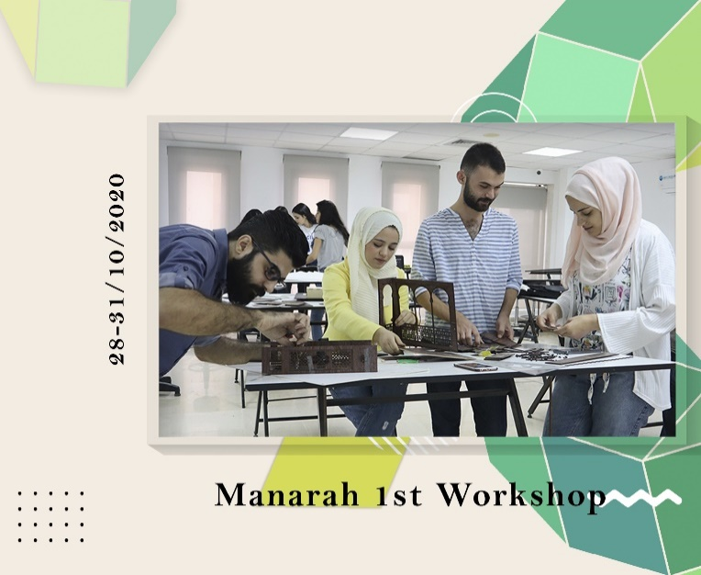**WP 6: DEVELOPMENT**

**Date:** 28-31/10/2020 **Location:** Manara University

A 4-day HANDS workshop focused on traditional architectural elements. Prof. Al Assaf (MU rector) highlighted the importance of heritage preservation, and Prof. Wadah & Mrs. Karajally presented on heritage and crafts. Students designed chosen elements, then applied their designs using AutoCAD and created maquettes with various materials. The workshop culminated in a presentation, exhibition, and certificate distribution.